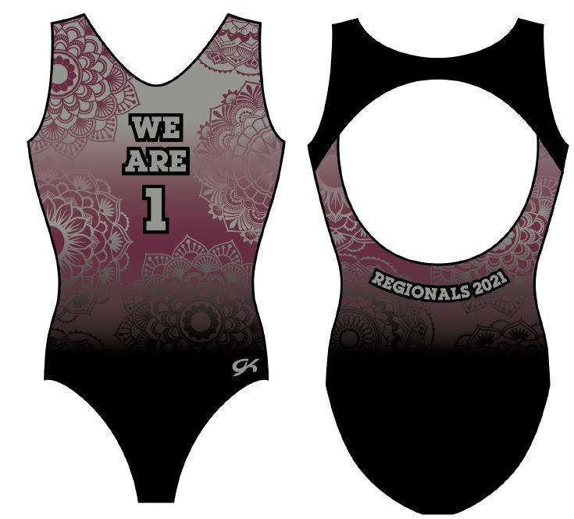
Region 1 Xcel Regionals
Commemorative Leotard
To commemorate your achievement of qualifying to Regionals, GK has designed this special sublimated leotard incorporating a Regionals Theme. The leotard is sublimated in our Region colors with “We are 1” saying and Regionals 2021 on back.

- Pre-Orders For this XCEL Version Must Be Received by APRIL 14 LATEST = $59.00 Discounted Rate - INCLUDES TAX.
- Orders received after preorder date of April 14th = $65.00 (inc. tax) + $8.50 shipping = $73.50

All pre-orders will be available for pick-up at XCEL REGIONALS.

Any orders received after the deadline above: will be shipped directly to you 4 – 6 weeks AFTER XCEL REGIONALS commences regardless of order date. Please note the online orders are marked as IN PROCESS once they are downloaded but will not ship until 4 - 6 weeks after Regionals as stated here as they will need to be manufactured when not included in the pre-orders.

PLEASE PRE-ORDER ONLINE at: www.iFlipSports.com
(This is a temporary website used for fundraiser orders). Orders are shown as pick up at store DISREGARD THIS - the preorders are marked this way to bypass website from charging you shipping fees. Pick up IS AT XCEL REGIONALS = no shipping. Thank you.

Presented by: Your REGION 1 local GK Elite Sportswear Representative: Lisa Behm
These CUSTOM State leotards cannot be returned or exchanged….all sales are final.
Phone (602)739-5381

A portion of the proceeds from PRE-sales of these leotards helps to benefit the ENTIRE REGION’s Gymnastics Clubs. This is a Fundraiser for OUR Great Athletes!

(On Line Credit Card Charge goes thru Square & shows on your statement as iFlip Sports Apparel/Elite Sportswear AZ)

