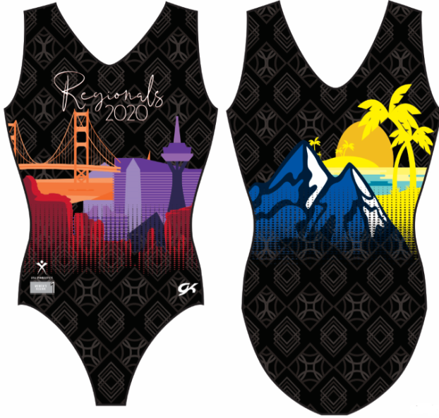
Level 8-10 Regionals 2020 Commemorative Leotard
To commemorate your achievement, GK has designed this special leotard. The leotard is sublimated on our super soft subfuse material with scenes from every State in Region 1.
- Pre-Orders received by March 24th = $49.00 tax included.
- Order received after March 24th = $49.00 (inc. tax) + $6.00 shipping = $55.00

All pre-orders will be available for pick-up at the Level 8-10 Regional Meet. Any orders received after March 24th will be shipped directly to you 4-6 weeks after the State meet.

To order please use one of the following methods:
1. Email-Please return this form to: Marygrace Gavino at gkmgavino@gmail.com
2. Venmo- @GKBayArea_ Please include gym name, contact info and size in comments.
3. Phone orders (925) 808-8778
Regional leotards cannot be returned or exchanged….all sales are final. *please note pilling may occur on sublimation fabric. No returns will be accepted for pilling.

4. Mail form and check payable to GK Bay Area
GK Bay Area
2982 W. Castle Pines Terrace
Dublin, Ca 94568

This is a Region 1 fundraiser. A portion of proceeds directly benefits all of Region 1 Gymnastics.
- - - - - - - - - - - - - - - - - - - - - - - - - - - - - - - - - - - - - - - - - - - - - - - - - - - - - - - - - - - - - - - - -- - - -- - - -- - -
To order, please complete the following: Circle LEVEL- 8 9 10

Gym Club Name:____________________________________State:__________
Athlete’s Name:_____________________________________
Please circle your GK Elite Sportswear Size:
CS CM CL AXS AS AM AL AXL
Phone#:__________________________________________
Email:___________________________________________
Address:______________________________________________________________
_________________________________________________

Payment Information:
Credit Card #:__________________________________________________________
Exp:_________ Security code:_______ Zip code associated with card:__________
Account Holder Name:_______________________________ phone #:______________________

